**USER MANUAL**

1. **About Tab**

Introduces the user to our program

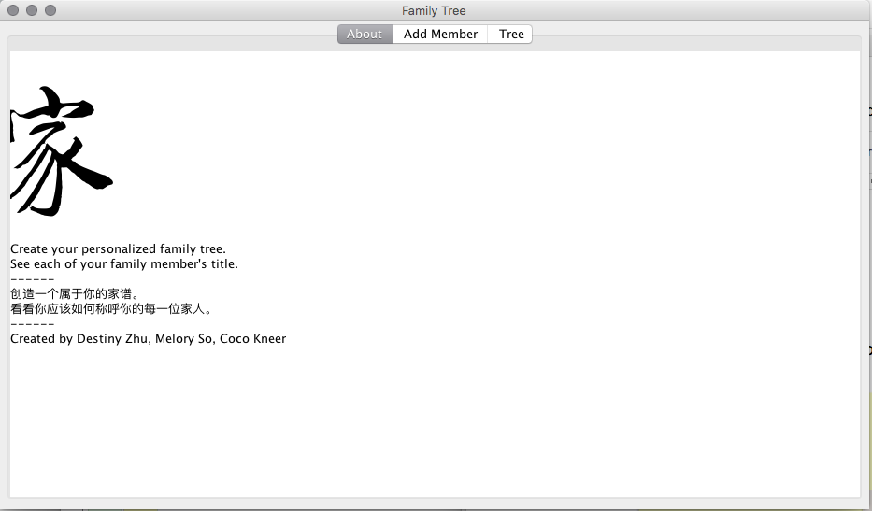

1. **Add Member Tab**

Program starts by adding your information

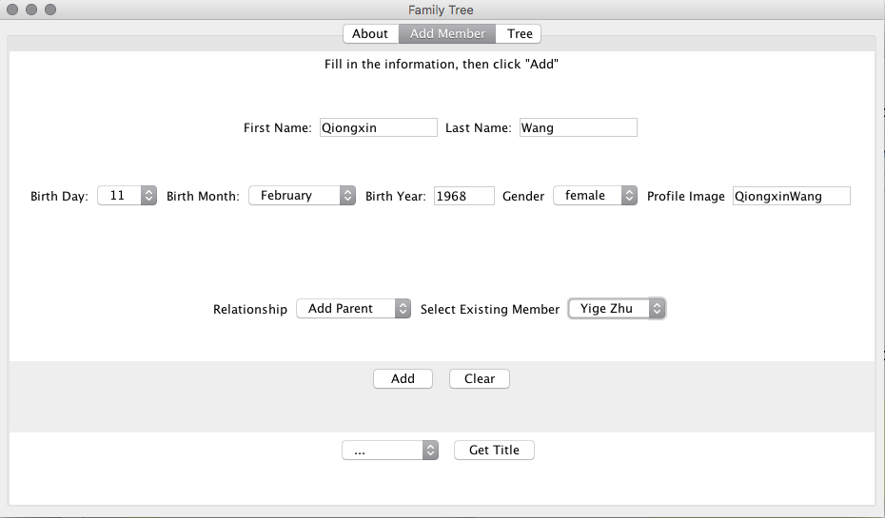

Additional family members can be added based on immediate family relations (eg. your grandmother is added as the mother of your mother)

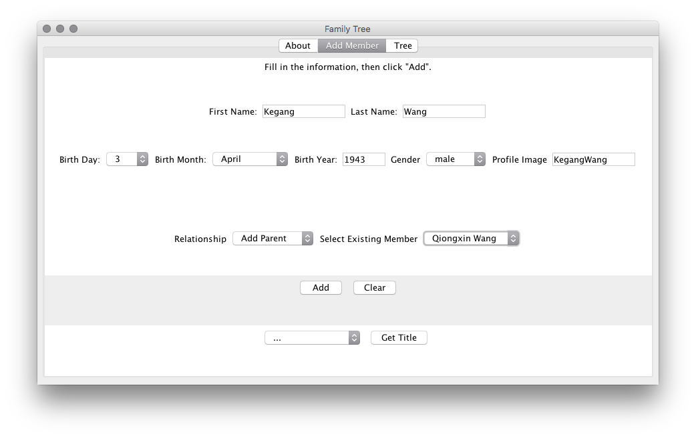The user accesses the Get Title button at the bottom to obtain the title of the selected family member (in Chinese).

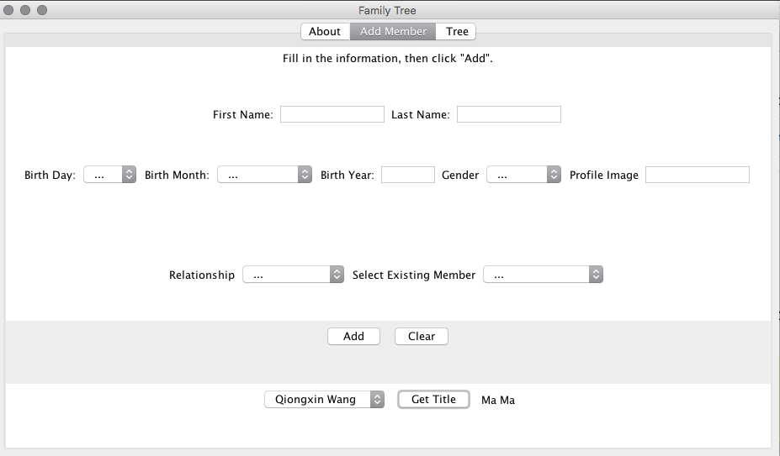

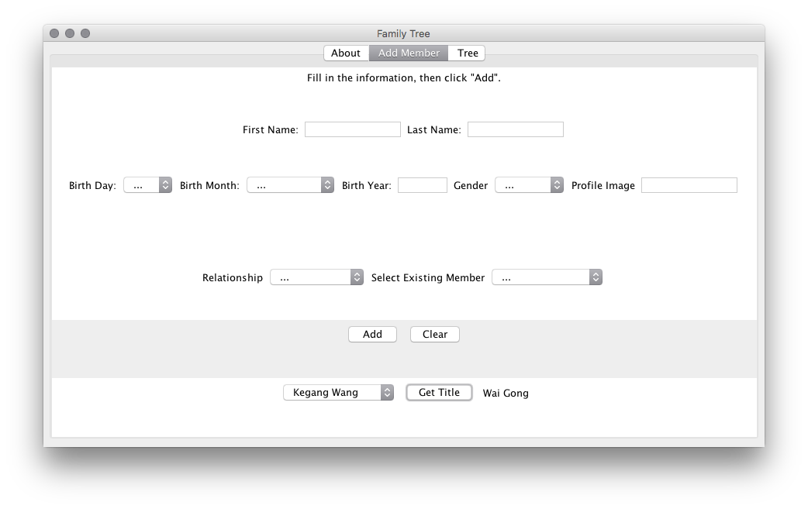

1. **Tree Tab**

Displays the family tree using information the user has inputted

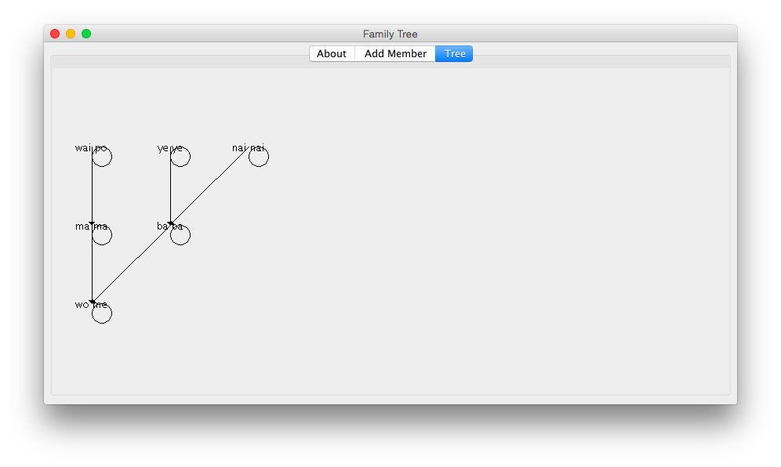

It updates automatically as more members are added

